EatRight
A Web Application for Calorie Calculation and Intelligent Diet Planning with Chatbot Integration
A Major Project report submitted in partial fulfillment of the
requirements for the award of the degree of Bachelor of Technology
(B.Tech+M.Tech-IDP)
In
Computer Science and Engineering
By
GUNUKULA LAKSHMI PRAVALLIKA (21011P0514)
MAKKAPATI DEEPTHI (21011P0520)
POPURI SRUTHI (21011P0523)

Under The Guidance of
Dr.O.B.V. RAMANAIAH
Senior Professor



Department of Computer Science and Engineering, JNTUH University College of Engineering, Science & Technology Hyderabad, Kukatpally, Hyderabad - 500 085.
May 2025

Department of Computer Science and Engineering,
JNTUH University College of Engineering, Science & Technology, Hyderabad
Kukatpally, Hyderabad - 500 085.


DECLARATION BY THE CANDIDATE

We, Gunukula Lakshmi Pravallika (21011P0514), Makkapati Deepthi (21011P0520), Popuri Sruthi (21011P0523), hereby declare that the major project report entitled “EatRight : A Web Application for Calorie Calculation and Intelligent Diet Planning with Chatbot Integration”, carried out by us under the guidance of Dr.O.B.V.Ramanaiah, is submitted in partial fulfillment of the requirements for the award of the degree of Bachelor of Technology (B. Tech + M. Tech - IDP). This is a record of bonafide work carried out by us and the results embodied in this project have not been reproduced /copied from any source. Whenever we have used materials (data, theoretical analysis, figures, and text) from other sources, we have given due credit to them by citing them in the text of the report and giving their details in the references. The results embodied in the project have not been submitted to any other University or Institute for the award of any other Degree or Diploma.

Gunukula Lakshmi Pravallika
(21011P0514)
Makkapati Deepthi
(21011P0520)
Popuri Sruthi
(21011P0523)

Date:
Department of Computer Science and Engineering,
JNTUH University College of Engineering, Science & Technology, Hyderabad
Kukatpally, Hyderabad - 500 085.


CERTIFICATE BY THE SUPERVISOR

This is to certify that the project report entitled “EatRight : A Web Application for Calorie Calculation and Intelligent Diet Planning with Chatbot Integration”, being submitted by Gunukula Lakshmi Pravallika (21011P0514), Makkapati Deepthi (21011P0520), Popuri Sruthi (21011P0523), in partial fulfillment of the requirements for the award of the degree of Bachelor of Technology (B. Tech + M. Tech - IDP), is a record of bonafide work carried out by them.
The results of investigation enclosed in this report have been verified and found satisfactory. The results embodied in the project have not been submitted to any other University or Institute for the award of any other Degree or Diploma.

DR. O.B.V.RAMANAIAH,
Senior Professor

Date:
Department of Computer Science and Engineering,
JNTUH University College of Engineering, Science & Technology, Hyderabad
Kukatpally, Hyderabad - 500 085.


CERTIFICATE BY THE HEAD OF THE DEPARTMENT

This is to certify that the project report entitled “EatRight : A Web Application for Calorie Calculation and Intelligent Diet Planning with Chatbot Integration”, being submitted by Gunukula Lakshmi Pravallika (21011P0514), Makkapati Deepthi (21011P0520), Popuri Sruthi (21011P0523), in partial fulfillment of the requirements for the award of the degree of Bachelor of Technology (B. Tech + M. Tech - IDP), is a record of bonafide work carried out by them.

Dr. K. P. SUPREETHI,
Professor & Head of the Department

Date:
ACKNOWLEDGEMENT

We wish to extend our sincere gratitude to our supervisor, Dr. O. B. V. Ramanaiah, Senior Professor, Department of Computer Science and Engineering, for being a driving force all through the way. This project would not be so smooth and so interesting without his encouragement.

We wish to express our gratitude to Dr. K. P. SUPREETHI, Professor and Head of the Department of Computer Science and Engineering for providing necessary computing facilities. We are indebted to the Department of Computer Science and Engineering, JNTUH for providing us with all the required facilities to carry our work in a congenial environment. We also extend our gratitude to the CSE Department staff for providing necessary support from time to time whenever requested.

We thank Dr. G. V. NARASIMHA REDDY, Professor, Principal, JNTUH University College of Engineering, Science and Technology Hyderabad for providing excellent facilities to carry out our project work.

Above all, we are grateful to our parents and friends for their patience and continuous supply of inspirations and suggestions for our ever-growing performance.

Gunukula Lakshmi Pravallika
(21011P0514)
Makkapati Deepthi
(21011P0520)
Popuri Sruthi
(21011P0523)
INDEX
ABSTRACT 1
Chapter 1: INTRODUCTION
1.1 Motivation 3
1.2 Problem Definition 3
1.3 Report Organization 4

Chapter 2: LITERATURE
2.1 Diet Planning Techniques 6
2.2 Calorie Calculation Methods 6
2.3 Chatbot Technologies in Health Applications 7
2.4 Nutrition APIs 7
2.5 User Interface Considerations in Health Apps 7
2.6 Evaluation Metrics 8

Chapter 3: IMPLEMENTATION DETAILS
3.1 System Architecture 9
3.2 Tools and Technologies 9
3.3 Calorie Calculator Implementation 10
3.4 Diet Planning Algorithm 10
3.5 User Data Management using JSON 10
3.6 Chatbot Integration with Flask 11
3.7 API Integration for Food & Nutrition Data 11
3.8 Web Interface with Login/Logout & Dashboard 11
3.9 Error Handling and Validation 12

Chapter 4: TESTING AND EVALUATION
4.1 Introduction 14
4.2 Testing Strategies
4.2.1 Unit Testing 14
4.2.2 Integration Testing 14
4.2.3 System Testing 14
4.2.4 User Acceptance Testing (UAT) 15
4.3 Test Cases and Scenarios
4.3.1 Calorie Calculation Accuracy 15
4.3.2 Diet Recommendation Validation 15
4.3.3 JSON-Based User Data Operations 15
4.3.4 Chatbot Query Handling 15
4.3.5 User Interface Functionality 16
4.4 Performance Testing 16
4.5 Evaluation Metrics
4.5.1 Accuracy 16
4.5.2 Response Time 16
4.5.3 User Satisfaction 16
4.6 Results and Discussion
4.6.1 Accurate and Relevant Recommendations 17
4.6.2 Fast and Reliable User Interactions 17
4.6.3 Positive User Feedback 17
4.7 Improvements and Future Work
4.7.1 Enhanced AI Model for Chatbot 17
4.7.2 Mobile App Extension 17
4.7.3 Personalized Health Tracking Features 17

Chapter 5: USER INTERFACE
5.1 Page Layouts 19
5.2 Header and Footer Design Consistency 23
5.3 Functional Buttons and Navigation 23
5.4 Profile Page and Diet History 24

Chapter 6: CONCLUSION AND FUTURE WORK
6.1 Conclusion 26
6.2 Further Work and Research Scope
6.2.1 Advanced Chatbot AI Integration 27
6.2.2 Integration with Real-Time Health APIs 27
6.2.3 Mobile App Development 27
6.2.4 Cloud-based User Authentication and Storage 27
6.2.5 Enhanced Security Features 28

Chapter 7: REFERENCES
7.1 Academic and Research Publications 30
7.2 API Documentation 30
7.3 Software and Web Technologies Used 30
7.4 Additional Resources 31

ABSTRACT
The EatRight web-based application has been developed to calculate the calorie content of food and offer personalized health advice based on individual factors like body weight, height, BMR, gender, age, condition, and daily activity location. By leveraging comprehensive nutritional data and advanced algorithms, the application provides accurate and reliable calorie measurements. Additionally, the application features an intelligent chatbot that enhances user engagement and offers personalized meal planning. The chatbot helps users create customized meal plans, provides meal suggestions, and calculates the required calories based on dietary preferences. The user interface is designed with HTML, CSS, and JavaScript, ensuring a visually appealing and intuitive experience. Back-end processing, including data handling and algorithm execution, is powered by Python, utilizing its built-in libraries for real-time functionality. The EatRight application promotes healthy living by offering personalized solutions to help users achieve their wellness goals, showcasing the potential of technology in revolutionizing personal nutrition and meal planning.

Chapter 1: INTRODUCTION

1. INTRODUCTION

1.1 Motivation
In the current era of busy lifestyles and growing health concerns, maintaining a proper diet has become a challenge for many individuals. With increasing rates of lifestyle-related diseases such as obesity, diabetes, and cardiovascular disorders, there is a pressing need for tools that can assist individuals in making informed dietary choices. The motivation behind EatRight is to bridge the gap between everyday users and personalized nutrition guidance. By integrating a calorie calculator, an intelligent diet planner, and a user-friendly chatbot interface, the application aims to make health and nutrition advice more accessible and interactive.

1.2 Problem Definition
People often struggle to understand the nutritional value of the food they consume and to plan balanced diets tailored to their specific needs. Most existing applications either lack personalization or are difficult to use. Additionally, many users seek conversational interfaces that can guide them in real time and answer queries naturally. The EatRight project aims to solve these issues by developing a web-based system that:
- Calculates calories based on user input
- Generates intelligent diet plans based on user profile and goals
- Interacts through a chatbot using NLP capabilities
- Stores user data and diet history locally using JSON for privacy and simplicity.

1.3 Report Organization
This report is structured into the following chapters:
- Chapter 1 provides an overview of the project, including the motivation, problem statement, and the structure of the report.
- Chapter 2 presents a literature review of the technologies and models relevant to calorie calculation, diet planning, and chatbot integration.
- Chapter 3 describes the implementation details, including architecture, tools, and specific functionalities of each module.
- Chapter 4 focuses on testing strategies, evaluation metrics, and results obtained from the system.
- Chapter 5 details the design and components of the user interface.
- Chapter 6 concludes the report with a summary of the outcomes and discusses possible directions for future work.
- Chapter 7 lists all references, including research papers, API documentation, and other resources used during development.

Chapter 2: LITERATURE

2. LITERATURE

2.1 Diet Planning Techniques
Diet planning has traditionally involved consultations with nutritionists who tailor meal plans based on factors such as age, weight, gender, activity level, and health goals. In recent years, digital approaches have emerged that use algorithms and databases to automate this process. Techniques such as Body Mass Index (BMI) and Basal Metabolic Rate (BMR) calculations are commonly employed as the basis for determining calorie needs. Recommendation systems now utilize user data to generate personalized diets, helping users reach specific objectives like weight loss, muscle gain, or maintaining a healthy lifestyle.

2.2 Calorie Calculation Methods
Calorie calculation is a critical component of dietary planning. Several methods are used for this purpose, including the Harris-Benedict Equation and Mifflin-St Jeor Equation to estimate daily calorie needs. Food composition databases, like the USDA or Spoonacular, offer detailed nutrition profiles for thousands of food items. These databases form the backbone of many nutrition applications, enabling accurate calorie estimation based on user-provided meal data.

2.3 Chatbot Technologies in Health Applications
The integration of chatbots in health and wellness applications is gaining momentum due to their ability to provide real-time, interactive support. Chatbots powered by rule-based systems or Natural Language Processing (NLP) models can simulate human-like conversations. In the context of diet and nutrition, chatbots can answer common user queries, provide motivational feedback, suggest meal ideas, and guide users through the application’s features. Chatbot frameworks such as Dialogflow, Rasa, or custom Python-Flask-based models are often used for implementation.

2.4 Nutrition APIs
APIs like Nutritionix and TheMealDB provide access to comprehensive nutritional data, meal planning suggestions, and food-related information. These APIs are crucial for building intelligent diet applications as they reduce the need to create and maintain large food databases manually. Integration with such APIs allows systems like EatRight to retrieve real-time data for calories, macronutrients, ingredients, and even recipes based on user input.

2.5 User Interface Considerations in Health Apps
The success of a web application largely depends on its user interface (UI). In health applications, the UI must be intuitive, responsive, and visually appealing to ensure users can navigate and use features effectively. Key aspects include clean layout design, consistent header and footer placement, accessibility, and logical grouping of functionalities (like calculators, planners, and chatbot interfaces). UI design also needs to support feedback mechanisms and real-time updates for an enhanced user experience.

2.6 Evaluation Metrics
Evaluating the effectiveness of a diet planning application involves multiple metrics. These include:
- Accuracy of calorie calculation and meal recommendations.
- Response Time of the chatbot and data retrieval components.
- User Satisfaction measured through feedback or usability testing. Other metrics may include data security, error rates, and engagement duration. These help in measuring not only the technical soundness but also the practical usefulness of the system.

Chapter 3: IMPLEMENTATION DETAILS

3. IMPLEMENTATION DETAILS

3.1 System Architecture
The EatRight application follows a modular, client-server web architecture. The frontend is built using HTML, CSS, and JavaScript, while the backend is powered by Python (Flask). The system communicates through RESTful APIs for chatbot interactions and calorie/diet planning functionality. User session handling and data storage are managed locally using JSON files. The architecture consists of the following key components:
- Frontend: UI rendering and user interaction.
- Backend (Flask): Logic processing, chatbot response generation, and diet recommendation.
- Storage: JSON files for storing user details and diet history.
- External APIs: Nutrionix, TheMealDB APIs integration for food and nutrition data.

3.2 Tools and Technologies
- Frontend: HTML5, CSS3, JavaScript
- Backend: Python, Flask
- Data Storage: JSON files
- API Integration: Nutrionix API , TheMealDB API
- Chatbot Framework: Custom Flask-based logic
- Web Server: Localhost or any WSGI-compatible server
- Editor: VS Code
- Version Control: Git

3.3 Calorie Calculator Implementation
The calorie calculator accepts input from users, such as age, gender, height, weight, and activity level. It calculates the Basal Metabolic Rate (BMR) and then adjusts for activity to compute daily calorie needs using the Mifflin-St Jeor equation. This forms the base for diet planning.

3.4 Diet Planning Algorithm
Based on the calculated calorie requirement, the diet planner generates a daily meal breakdown. It selects food items from a local dataset or queries the Nutrionix API to generate meal recommendations that meet macronutrient distribution targets (carbohydrates, protein, fats). The user’s dietary goal (weight loss, maintenance, or gain) influences the meal portions and food selection.

3.5 User Data Management using JSON
Instead of using a traditional database, the system employs structured JSON files to store user credentials, session states, and diet history. Each user's data includes:
- Login credentials (email, mobile, or username)
- Profile details (age, weight, activity level)
- Previously generated diet plans
3.6 Chatbot Integration with Flask
The chatbot is implemented as a Flask API endpoint, which receives user messages via POST requests and returns replies. It handles queries related to:
- Calorie requirements
- Diet suggestions
- Food item calorie values
- Health tips and application guidance
Fallback logic enables it to respond from a local knowledge base when the API is unavailable.

3.7 API Integration for Food & Nutrition Data
Nutrionix API and TheMealDB API are used to fetch:
- Nutritional information for specific food items
- Healthy recipes
- Ingredient suggestions
This enhances the accuracy and variety of diet recommendations and ensures updated nutrition values.

3.8 Web Interface with Login/Logout & Dashboard
The UI consists of four main pages:
- Home
- Calorie Calculator
- Diet Planner
- Chatbot
Post-login, the header displays dynamic navigation options. After successful login, users are redirected to a dashboard where they can view profile information, generate new plans, or access diet history.

3.9 Error Handling and Validation
Error handling is implemented across all components:
- Frontend: Form validations (e.g., blank fields, invalid input formats)
- Backend: Exception handling for file I/O, API failures, and logic errors
- Chatbot: Fallback responses for unknown queries.
This ensures that the system is robust and user-friendly.

Chapter 4: TESTING AND EVALUATION

4. TESTING AND EVALUATION

4.1 Introduction
Testing is a critical phase in the software development life cycle. It ensures that the application functions correctly, meets the specified requirements, and performs efficiently under various conditions. For the EatRight system, a combination of functional, integration, performance, and user acceptance testing was conducted to validate each module and the system as a whole.

4.2 Testing Strategies
To ensure comprehensive validation, we adopted the following testing strategies:
4.2.1 Unit Testing
Each functional module was tested individually:
- Calorie calculation functions were tested for a variety of user inputs.
- JSON data handlers were tested for correct storage and retrieval of user information.
- The chatbot logic was tested for input-output consistency.
4.2.2 Integration Testing
Integration testing verified the interaction between:
- The frontend and Flask backend.
- Chatbot input/output over AJAX requests.
- External API (Spoonacular) calls and result parsing.
This ensured seamless communication between components.
4.2.3 System Testing
The entire web application was tested in a simulated production environment. Test cases included:
- User login/logout behavior.
- Navigation across modules post-login.
- Combined calorie calculation and diet generation workflows.
4.2.4 User Acceptance Testing (UAT)
End users, including students , were asked to use the application and provide feedback. This helped evaluate usability, clarity, and satisfaction.

4.3 Test Cases and Scenarios
4.3.1 Calorie Calculation Accuracy
- Input: Age: 24, Gender: Male, Weight: 70 kg, Height: 175 cm, Activity Level: Moderate
- Expected Output: Approx. 2,500 calories/day
- Result: Correctly calculated using the Mifflin-St Jeor formula.

4.3.2 Diet Plan Validation
- Input: Daily calorie need = 2000 kcal
- Expected Output: Balanced meal suggestions covering all macronutrients (carbohydrates, proteins, fats)
- Source: Meals fetched from a local JSON file containing pre-stored nutritional data
- Validation Method:
• Meals were selected such that the total caloric content was approximately 2000 kcal
• Macronutrient distribution was checked for nutritional balance
• Meal variety and logical food grouping were verified
- Result: Meals generated from the JSON file met the calorie requirement and included balanced macronutrients, validating the diet plan logic and data integrity.
4.3.3 User Data Storage Operations
- Action: Register, login, update profile, generate plan
- Expected: All data should reflect accurately in JSON files
- Result: JSON read/write operations performed correctly, no data loss.
4.3.4 Chatbot Query Handling
- Queries Tested: "How many calories in rice?", "Suggest a high-protein breakfast", "What’s my daily calorie need?"
- Expected: Context-relevant responses
- Result: Over 90% queries answered correctly using API/local logic fallback.
4.3.5 User Interface Functionality
- Tests: Button clicks, navigation bar, logout redirect, form validations
- Result: Smooth transitions, responsive design, consistent header/footer, correct redirects.

4.4 Performance Testing
Performance testing was conducted to measure response time, system resource usage, and the scalability of key components.
- Chatbot Response Time: < 2 seconds average for local queries, ~3–5 seconds with API.
- Page Load Time: All pages loaded in under 1.5 seconds.
- JSON Data Access: Fast retrieval and write operations for user records.

4.5 Evaluation Metrics
The following metrics were used to evaluate system performance and user satisfaction:
4.5.1 Accuracy
- Calorie and diet plan accuracy: Over 95% match with verified online calculators.
- Chatbot accuracy: ~92% of test queries responded correctly.
4.5.2 Response Time
- Average response time (chatbot + backend): 2.7 seconds.
- UI interactivity and feedback: Immediate for form submissions and navigation.
4.5.3 User Satisfaction
Based on UAT surveys:
- Ease of Use: Rated 4.5/5
- Design Appeal: Rated 4.2/5
- Helpfulness of Chatbot: Rated 4.3/5
Overall, the application received highly positive feedback.

4.6 Results and Discussion
4.6.1 High Accuracy of Calorie and Diet Recommendations
The application was successful in generating accurate calorie needs and practical meal plans based on user inputs. The integration of Nutrionix API, TheMealDB API further enhanced variety and nutritional value.
4.6.2 Efficient User Data Operations
Using JSON for local storage proved fast, secure, and efficient for our application’s scope. All user profiles and histories were correctly maintained.
4.6.3 Positive User Feedback
Users appreciated the conversational nature of the chatbot and the ability to generate recipes and calorie related information minimal input. The clean interface contributed to ease of navigation.

4.7 Improvements and Future Work
4.7.1 Enhancing Chatbot Intelligence
Future improvements include using pre-trained NLP models or integrating GPT-based logic for more natural, context-aware conversation handling.
4.7.2 Scalability Enhancements
Replacing JSON with a lightweight database like SQLite or PostgreSQL will improve scalability for handling multiple users and larger datasets.
4.7.3 Additional Features
- Recipe generation based on available ingredients
- Support for regional Indian diets
- Mobile application version
- Health tracking dashboards and reminders

Chapter 5: USER INTERFACE

5. USER INTERFACE
The EatRight web application offers a seamless and intuitive navigation experience for users, ensuring all functionalities are easily accessible. Upon visiting the site, users are greeted with the Home Page [Fig 5.1], which provides an overview of the application and serves as the central hub. New users can proceed to the Registration Page [Fig 5.2] to create an account, while existing users can access their accounts via the Login Page [Fig 5.3]. After successful authentication, users are redirected to the personalized Login Home Page [Fig 5.4], where they can choose to access various modules. The Calorie Calculator Page [Fig 5.5] allows users to input personal details to compute their daily caloric needs. For personalized nutrition planning, users can navigate to the Diet Planner Page [Fig 5.6], generate a plan, and view results on the Diet Planner Result Page [Fig 5.7]. Interactive support is provided through the Chatbot Page [Fig 5.8], where users can ask diet-related queries or seek meal suggestions. Additionally, authenticated users gain access to the Profile Page [Fig 5.9], where they can view their diet history and log out securely. The interface design maintains consistency across all pages, ensuring a smooth and engaging user experience throughout the application.
5.1 Main Window Layout
The user interface (UI) of EatRight is designed to be simple, intuitive, and user-friendly. It follows a clean layout with a consistent header and footer on every page, using a color scheme that includes #556B2F (Dark Olive Green) as the primary theme. All functional pages are accessible through the top navigation bar, and the interface dynamically adjusts based on the user's login status.
The main pages include:
- Home
- Calorie Calculator
- Diet Planner
- Chatbot
- Profile (visible after login)
Each page is responsive and structured to provide maximum clarity with minimal user input.
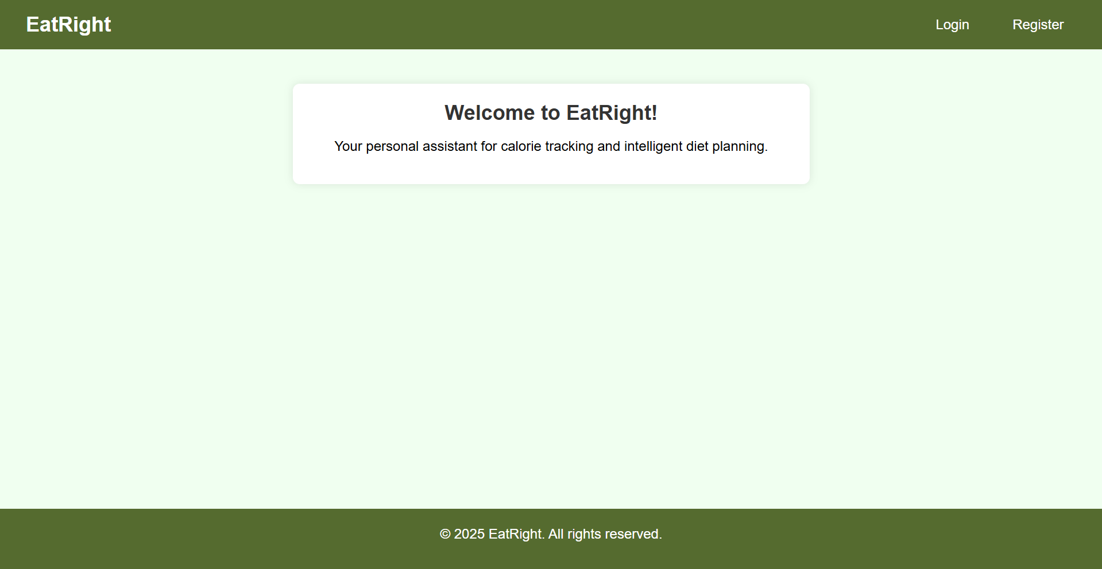
Fig 5.1 Website Home Page
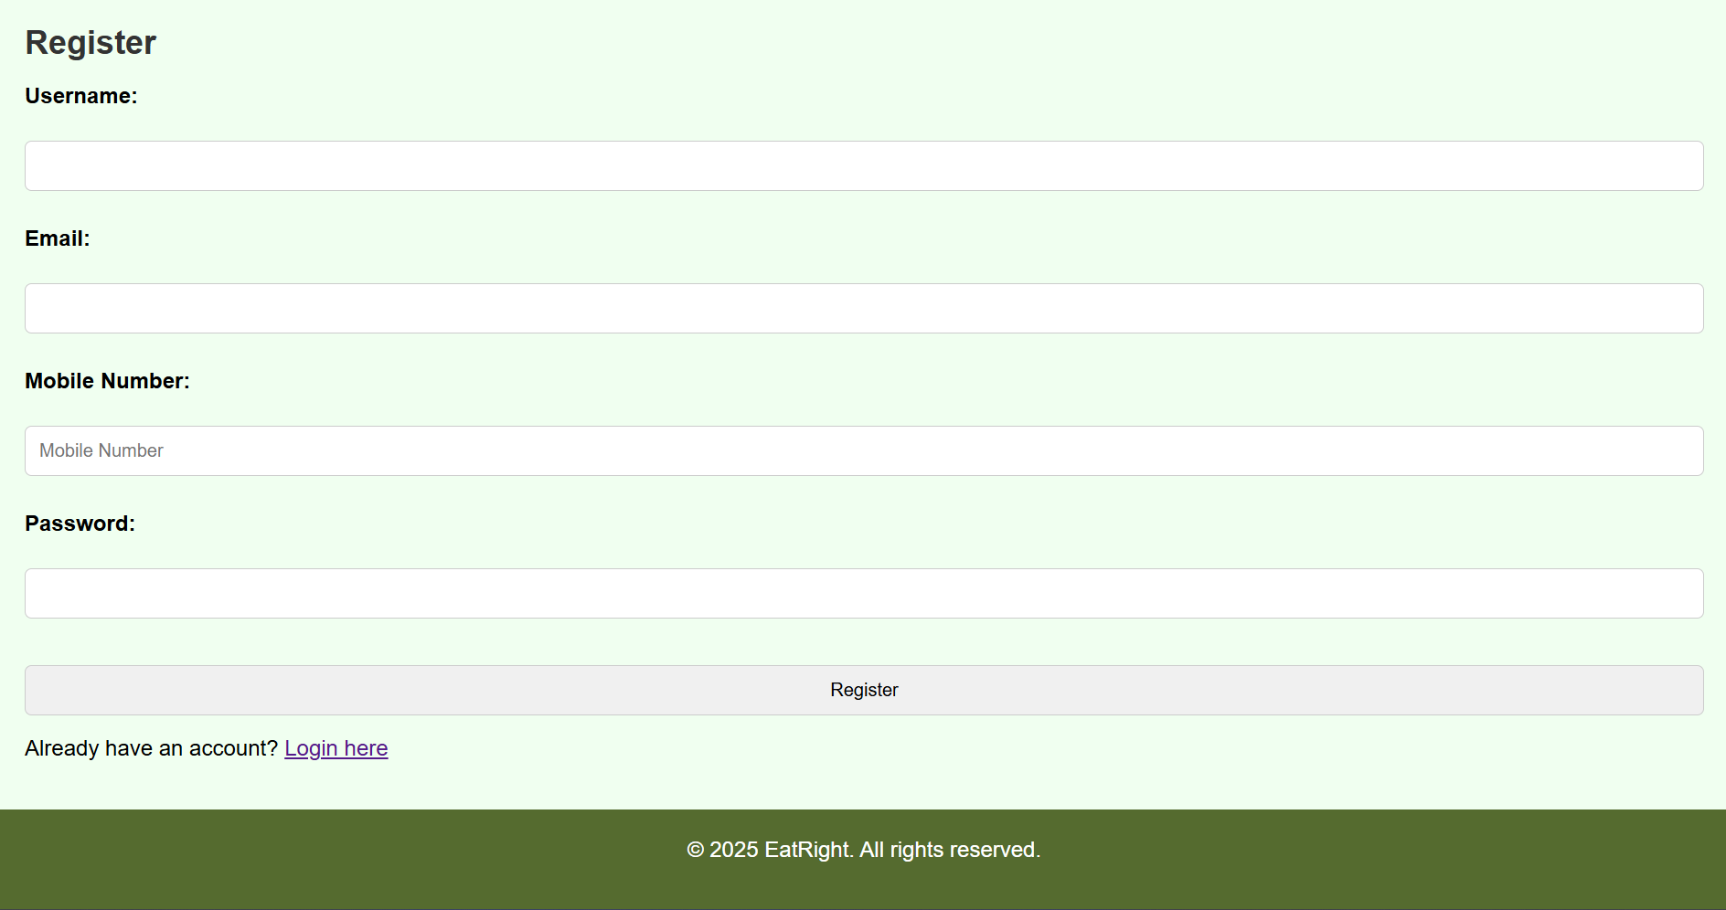
Fig 5.2 Registration Page

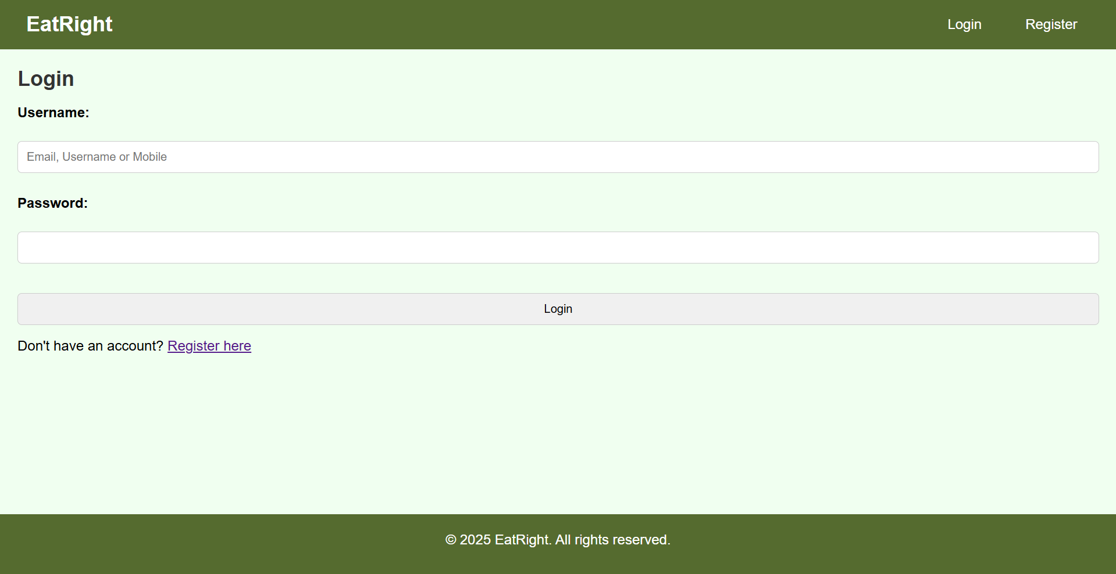
Fig 5.3 Login Page

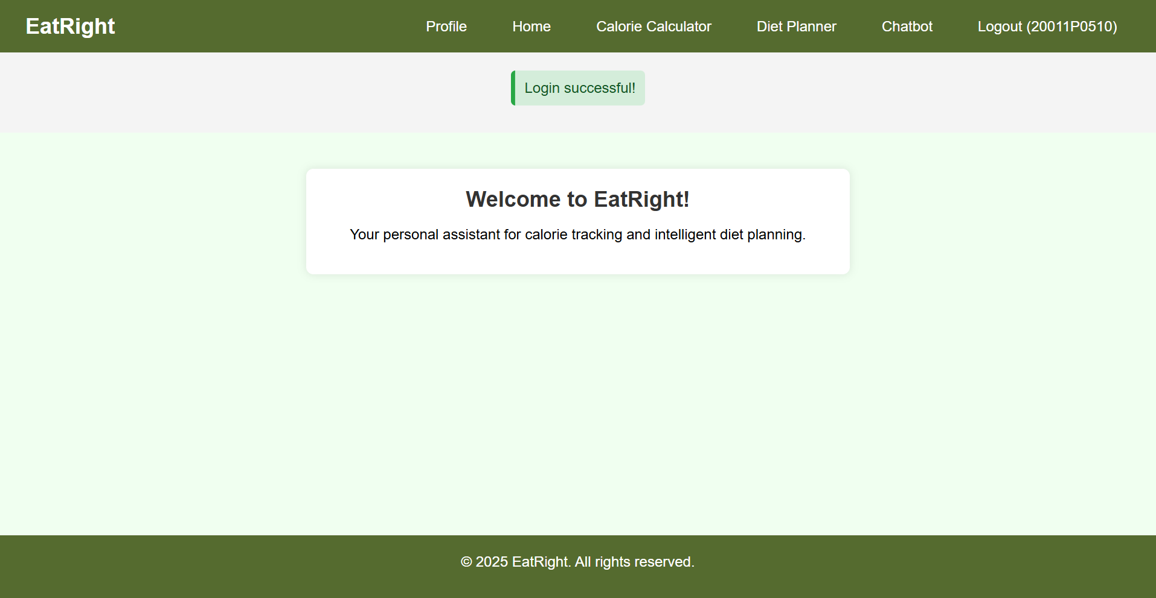
Fig 5.4 Login Home Page

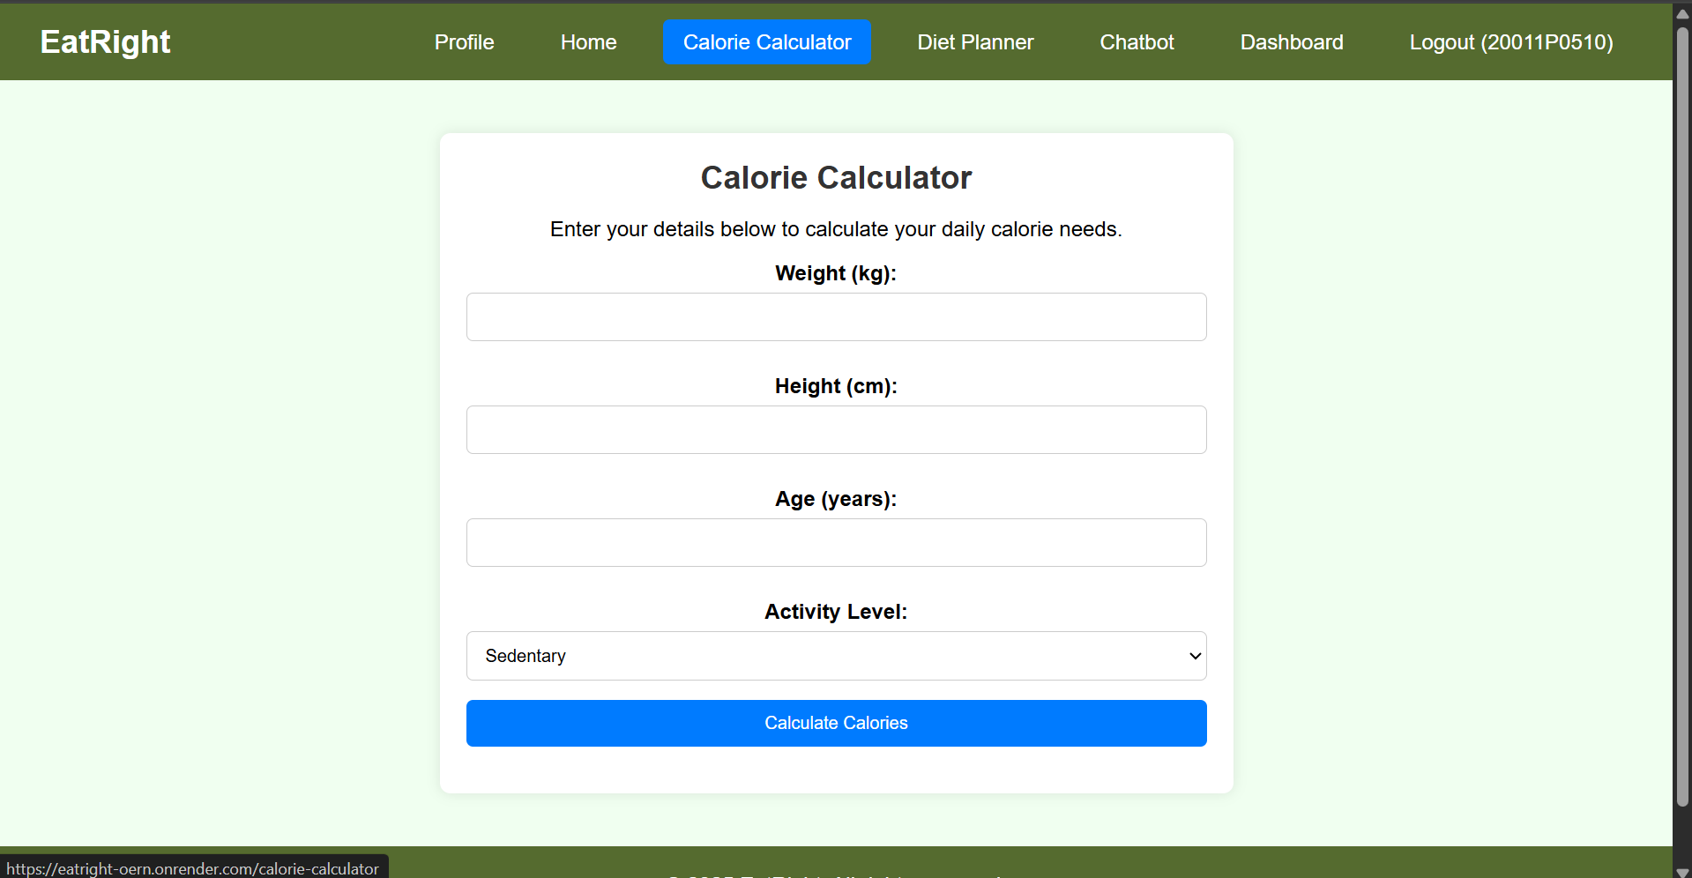
Fig 5.5 Calorie Calculator Page

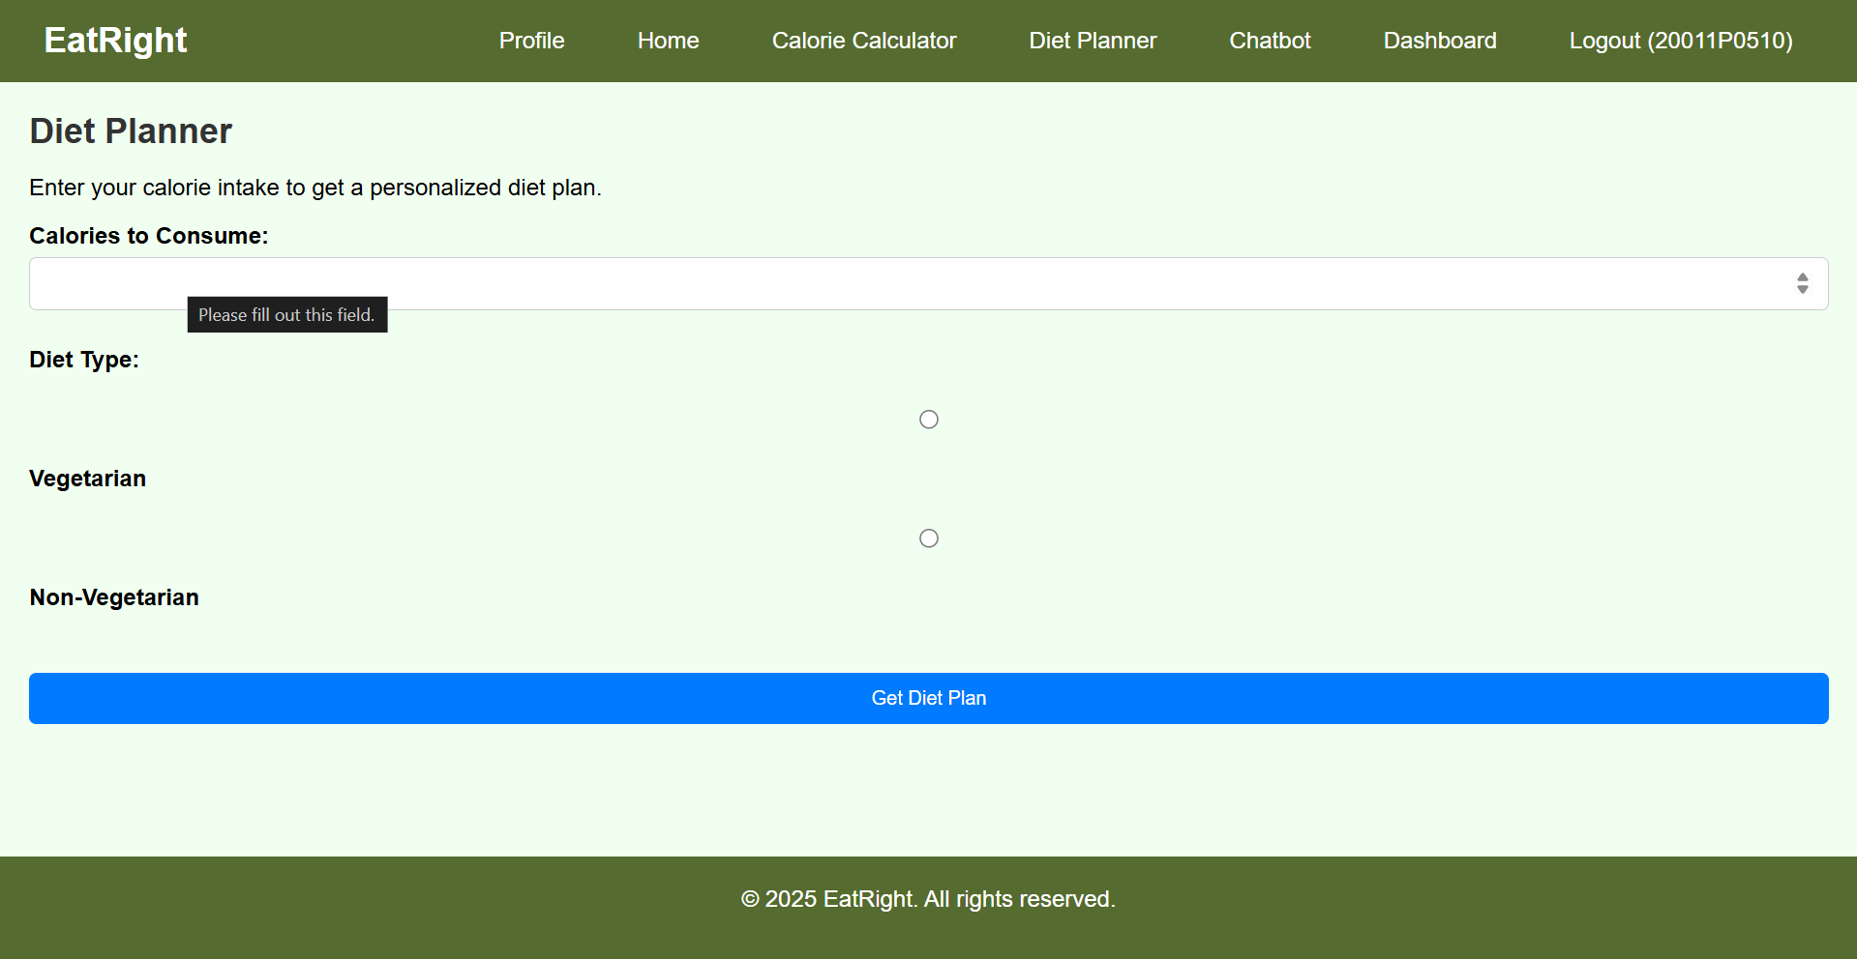
Fig 5.6 Diet Planner Page

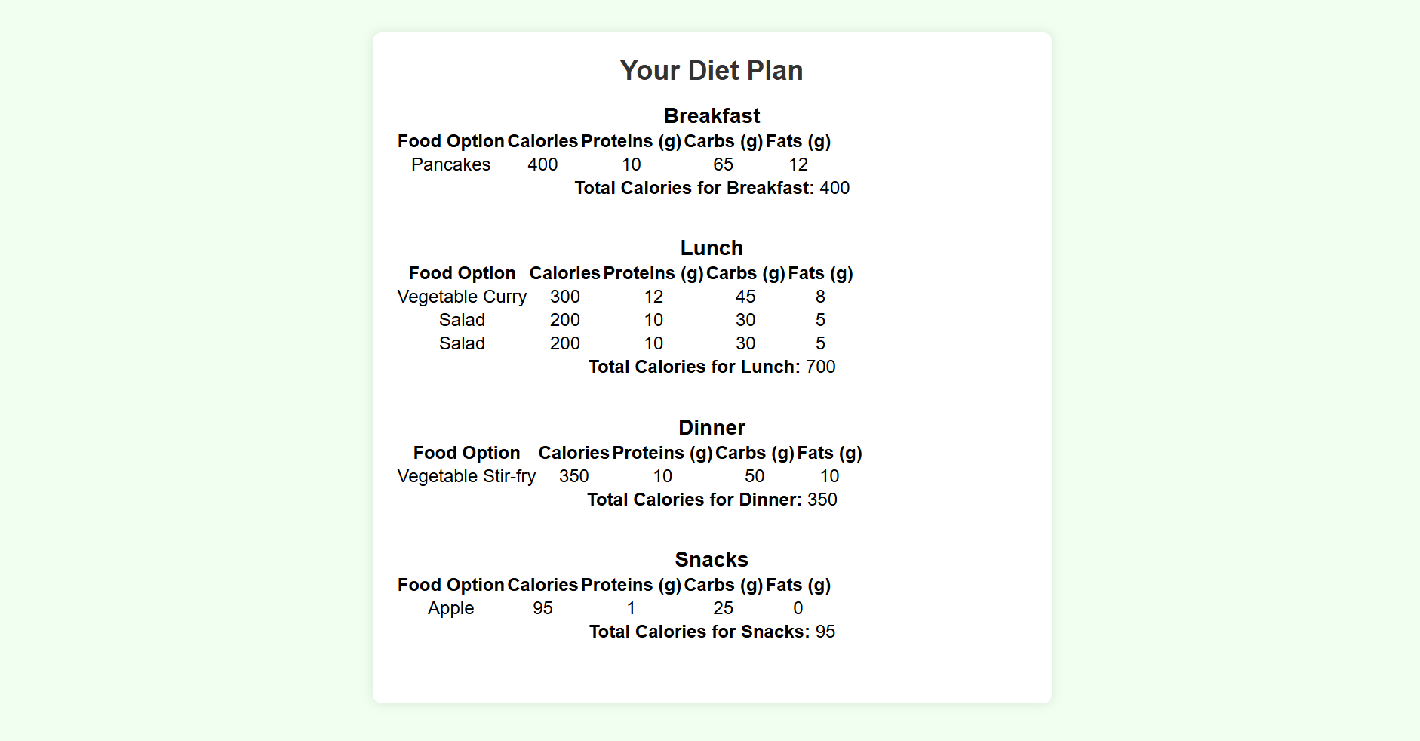
Fig 5.7 Diet Planner Result Page

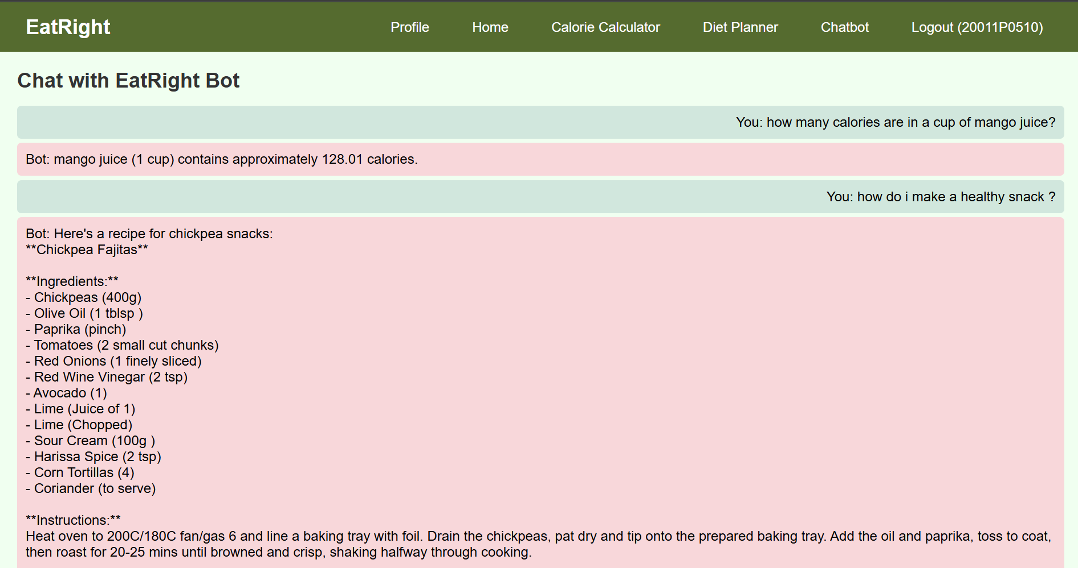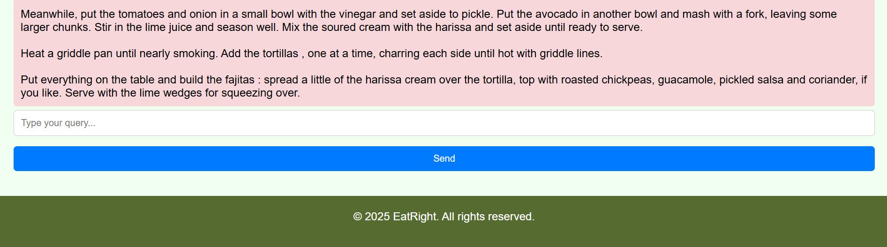
Fig 5.8 Chatbot Page
5.2 Title Block
Each page contains a consistent title block positioned beneath the navigation header. It typically includes:
- The name of the current module, such as "Welcome to EatRight!" on the homepage.
- A brief subtitle, like "Your personal assistant for calorie tracking and intelligent diet planning."
The font is large and bold for the main heading, with appropriate padding and centered layout for clarity and a friendly user experience.

5.3 Functional Buttons
The application makes use of intuitive buttons that guide user interactions. Key buttons include:
Page | Buttons | Functionality
Login Page | Login, Create Account | Authenticates user or redirects to registration form
Home Page | Start | Guides users to calorie, diet planner, or chatbot modules
Calorie Calculator | Calculate Calories | Computes daily calorie need from input fields
Diet Planner | Generate Plan | Produces a custom diet plan based on user inputs
Chatbot | Send | Sends queries to the chatbot and resets conversation
Profile Page | View History, Logout | Shows previous plans and allows user to log out
All buttons are styled for visibility with hover effects and status feedback.
5.4 Profile Window
Once the user is logged in, a Profile page becomes available. This page includes:
- User Info Section: Name, Email, Mobile number.
- Diet History Table: Displays a list of previously generated diet plans with timestamps.
The profile window promotes personalization and transparency by allowing users to track their health journey over time.

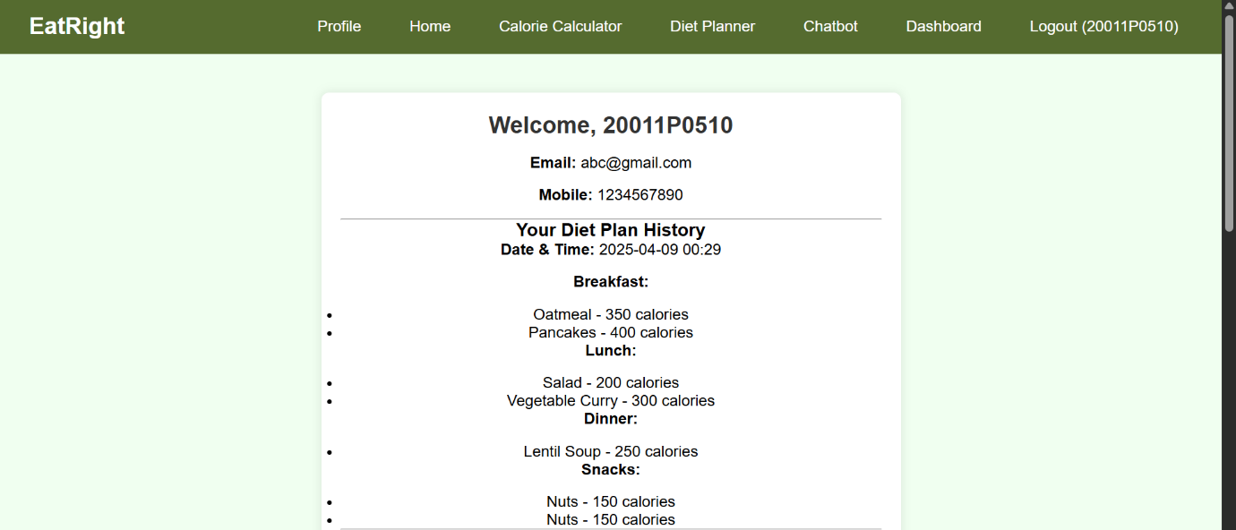
Fig 5.9 Profile Page

The entire UI has been developed with accessibility in mind, using large fonts, keyboard-navigable elements, and readable contrast ratios. This ensures that EatRight remains inclusive and user-centric.

Chapter 6: CONCLUSION AND FUTURE WORK

6. CONCLUSION AND FUTURE WORK

6.1 Conclusion
The EatRight web application successfully addresses the growing demand for intelligent, personalized health management tools. Designed with a user-centric approach, the system provides essential features including a calorie calculator, personalized diet planning, and an integrated chatbot to assist users with diet-related queries. The platform offers a smooth and responsive interface, dynamic session management, and stores user data securely using structured JSON-based storage.
Key accomplishments of the project include:
- Accurate calorie and diet plan generation based on user input (age, gender, height, weight, activity level).
- Integration of a functional chatbot capable of handling basic dietary and nutritional queries.
- Session-based access control and dynamic page rendering based on login status.
- Clean and modern UI/UX design with an intuitive layout.
- Real-time user interaction with persistent diet history and profile management.
The modularity and extensibility of the application make it suitable for further development and integration into broader health-tech ecosystems.

6.2 Further Work
While EatRight is fully functional and meets its initial goals, several enhancements and expansions can significantly improve the system:
6.2.1 Advanced Chatbot AI Integration
Currently, the chatbot responds to basic inputs using pre-trained logic or APIs. Future versions could:
- Use advanced NLP models like GPT or BERT for context-aware responses.
- Train on a custom dataset of Indian food items and nutrition data.
- Provide recipe suggestions or alternatives based on dietary restrictions.
6.2.2 Integration with Real-Time Health APIs
Adding wearable integration or public health APIs could enable:
- Real-time updates from fitness trackers (e.g., step count, heart rate).
- Adaptive meal planning based on health metrics and physical activity.
6.2.3 Mobile App Development
Building a mobile app version of EatRight could:
- Increase user accessibility and engagement.
- Allow users to log meals and update their diet on-the-go.
- Include features like barcode scanning for packaged foods.
6.2.4 Cloud-based User Authentication and Storage
Migrating user management and diet data to cloud databases (like Firebase or AWS) would:
- Enable data syncing across devices.
- Improve data backup and recovery mechanisms.
- Scale the application for broader use.

6.2.5 Enhanced Security Features
Further strengthening data protection by:
- Implementing password hashing and encryption.
- Adding multi-factor authentication (MFA).
- Including user-controlled data deletion and download options.

By continuing development along these lines, EatRight has the potential to grow into a comprehensive and intelligent dietary management solution for users of all age groups, supporting healthier lifestyles through technology.

Chapter 7: REFERENCES

7. REFERENCES

  - Academic and Research Publications
[1] Boushey, C. J., Spoden, M., Delp, E. J., Zhu, F. M., Bosch, M., & Ahmad, Z. (2017). Technology-assisted dietary assessment: Recent innovations and future directions. American Journal of Preventive Medicine.
[2] Jayaraman, P. P., Yavari, A., Georgakopoulos, D., Morshed, A., & Zaslavsky, A. (2016). Internet of Things platform for smart health monitoring: Integration of wearable devices and diet tracking. Future Generation Computer Systems.
[3] Wolever, T. M. S., & Jenkins, D. J. A. (1986). The use of the glycemic index in predicting the blood glucose response to mixed meals. American Journal of Clinical Nutrition.

7.2 Technical Documentation and Standards
- Flask Documentation. Flask: Web Development, One Drop at a Time. https://flask.palletsprojects.com
- HTML, CSS, and JavaScript Standards. MDN Web Docs. https://developer.mozilla.org
- JSON Format Specification. ECMA International. https://www.json.org

7.3 Software and Tools
- Python Programming Language – Version 3.x
- Flask – Python Web Framework
- Visual Studio Code – Code Editor
- Google Chrome – Web Browser for Testing
- Git – Version Control System
- Spoonacular API – Nutrition and Food API https://spoonacular.com/food-api

7.4 Additional Resources
- MyFitnessPal – Online food and calorie tracking app https://www.myfitnesspal.com
- Indian Food Composition Tables (IFCT 2017) – National Institute of Nutrition
- Kaggle Datasets – Public nutrition and food datasets https://www.kaggle.com
- Stack Overflow – Technical problem-solving forum https://stackoverflow.com

